MODEL LESSON PLAN FOR ALL TYPES OF HIGH SCHOOLS
CLASS: 10 SUBJECTS: Biology Name of the Teacher: Name of the School:

Name of the Lesson/Unit | Topic | No. of Periods  Required | Timeline for teaching |  | Any specific  Information
 |  |  | From | To
Reproduction | Asexual mode of reproduction, Vegetative propagation | 2
 | Sexual reproduction | 3 |  |  | Discussion on IVF
 | Sexual reproduction in plants | 3
 | Cell division and continuation of life | 2
 | Reproductive health, Birth control measures, social evils | 2 |  |  | Awareness program on reproductive health by PHC doctor.

Prior Concept/ Skills: (Essential concepts and skills to be checked/bridged before teaching the current concept.)
Plant parts, flower parts, male gametes, female gametes, sperm cell, ovum, pollen grains, ovule, pollination, fertilization, oviparous, viviparous, life cycle of frog, germination of seeds, sexual reproduction, asexual reproduction, vegetative propagation examples.
Learning Outcomes: (Select from SCERT Academic Calendar and Textbook)  - Differentiates sexual and asexual reproductions, Grafting and layering, mitosis, and meiosis.  - Classifies the organisms based on their mode of reproduction.  - Plans and conducts investigations / experiments to examine the spores of Rhizopus and pollen tubes under the microscope.  - Explains the sexual reproduction in human beings, plants, cell cycle and mitotic division.  - Draws labelled diagrams of male and female reproductive systems, sperm cell, flower, and fertilization  - Analyses and interprets data in the pi graph of cell cycle.  - Applies learning to hypothetical situations, such as what happens if there is no mitosis / meiosis?  - Applies scientific concepts in daily life and solving problems, such as to develop saplings in gardening by using vegetative propagation, life takes precautions to prevent sexually transmitted infections and adopt safe contraceptive methods in future.  - Takes initiative to know about scientific discoveries / inventions with respect to cell divisions and continuation of life.  - Exhibits values of honesty / objectivity / rational thinking / freedom from myth / superstitious beliefs while taking decisions, respect for life, etc. Such as effect of child marriage and early pregnancy on physical and mental health of the individual and evil effects of female foeticide. | No. of Periods:  12

TEACHING LEARNING PROCESS
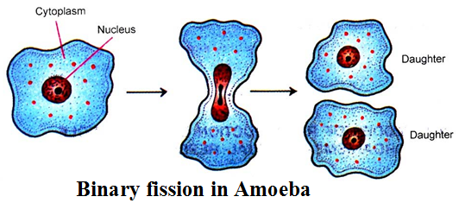
Induction/Introduction (Generating interest, informing students about the outcomes and expectations for the lesson)
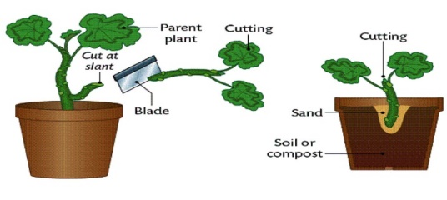
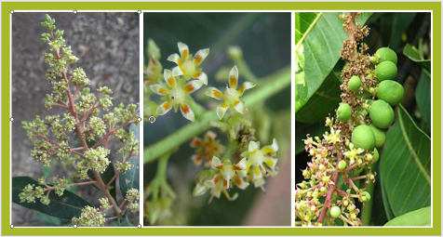
- How can we geta a new plant?
- What will you do to get new rose plant?
- Can we get a new plant without a seed?
- What did you observe the binary fission in amoeba?
- Where is the mother amoeba?
- What is the major difference among these three slides in reproduction?
Experience and Reflection (Task/question that helps students explore the concept and connect with their life)
- What is the type of reproduction by fusion of male and female gametes?
- What is the sexual part of plant?
- Which part of plant other than flower that give rise a new plant?
- Is it possible to give birth to baby without male and female?
Explicit Teaching/Teacher Modelling (I Do) | Group Work (We Do) | Independent Work (You Do)
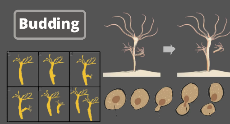  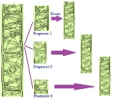  - Discussion and picture illustration of Asexual mode of reproduction.  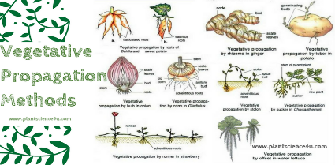  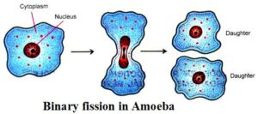  - Discussion and picture illustration of vegetative propagation.  - Discussion and demonstration of artificial propagation.  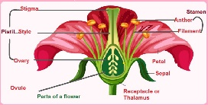  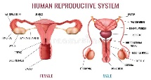  - Discussion and picture illustration of sexual reproduction in placental mammal – childbirth  - Discussion and specimen observation on sexual reproduction in plants.  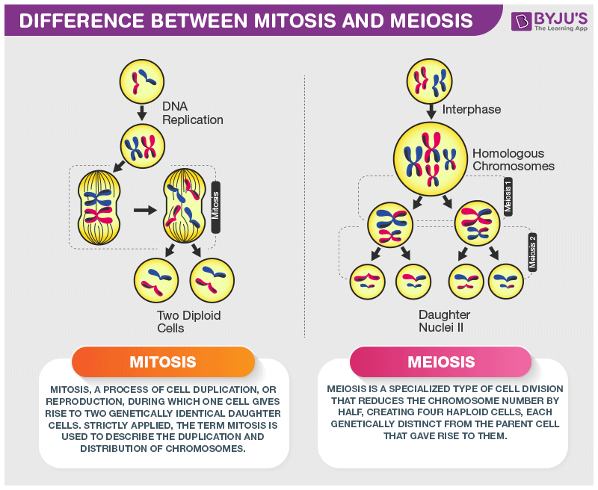  - Discussion on Cell division in human beings and cell cycle  - Observation of different stages of mitotic cell division (Activity – 4)  - Discussion and picture illustration on process of meiosis.  - Discussion on reproductive health, birth control methods and social ills. | 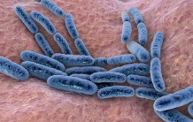  - Formation of bacterial colony milk (Activity -1)  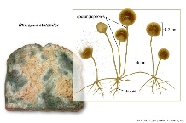  - Observation of Rhizopus under the microscope (Lab activity)  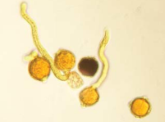  - Observation of pollen grains (Activity – 2)  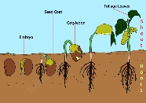  - Observation of seed germination (Activity -3)  - Provide the vocabulary related to Reproductive system such as fission, fragmentation, regeneration, parthenogenesis, vegetative propagation etc, make the students to arrange those words in the dictionary order and explain the meaning of each word in their own words.  - Conduct a seminar on contributions of different scientists in understanding of cell division and continuation of life. | - Draw the charts showing datura flower, structure of ovule, fertilisation in plants, male and female reproductive systems of human beings and sperm cell. (Creativity)  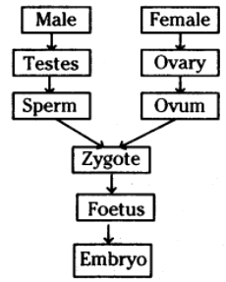  - Prepare flow charts showing sexual reproduction in human beings, life cycle of flowering plant. (Creativity, Critical thinking)  - Group discussion on teenage motherhood and female foeticide. Make the students prepare some slogans against the child marriages and female foeticide. (SEL)  - Conduct AIDS Day - discuss on skills needed for protecting oneself from the sexually transmitted diseases. (Communication, Collaboration) (S. Club)  - Give the flow chart showing sexual reproduction in plants and human beings and let them explain the process in their own words.  - Make the students prepare their own sentences using the hints given in the table. (Using by)  Paramoecium reproduces/ reproduce by fission  Yeast budding  Fungi fragmentation  Bees/ants/ wasps parthenogenesis  Planaria regeneration

Check For Understanding Questions  - Factual:  - What is budding?  - What is grafting?  - What are the contraceptive methods in male and female?  - What is double fertilization?  Open Ended / Critical Thinking:  - What happens to the wall of the uterus during menstruation?  - What happens if plant do vegetative propagation only?  - What happens if meiosis absents in sexual reproduction?  Student Practice Questions & Activities (Exercises from workbook / textbooks/ blackboard)  - Why do fish and frog produce a huge number of eggs each year?  - How are sperm cells adapted for their function?  - What does the mother’s blood take away from the baby and into the placenta?  - What are the advantages of sexual reproduction? | TLMs (Digital + Print)  Resources: Use the given Do ID to get the digital content related to this chapter on Diksha.  For basics of Reproduction: https://diksha.gov.in/play/content/do_31320682622453350417090  For types of Asexual Reproduction: https://diksha.gov.in/play/content/do_31320682628258201618190  For Sexual Reproduction In Animals https://diksha.gov.in/play/content/do_31320682642441830417091  For Sexual Reproduction in plants: https://diksha.gov.in/play/content/do_31320682635926732816017  Use the language lab pen drive resource.  Some of the other digital resources are:  https://www.youtube.com/watch?v=9ZCSvxOX49Q&list=PLfJPOhTTDi0nk3OOpUHya1DSvqr6i0-H3  Charts showing different asexual reproduction methods, Vegetative propagation methods, Structure of flower, fertilization, embryo sac, Male and female reproductive systems of human beings, spermatozoa, egg, development of embryo, cell cycle, mitosis and miosis.  Modals of male and female reproductive structure, developmental stages of embryo.  Microscope, bread, slides, stains, coverslips, needle, polyethene cover, water, sugar solution etc,.  Botany and Zoology text books of intermediate.
Assessment (Think of what children SAY, DO and MAKE while learning that can form the evidence of learning to be used for assessment).
- Write the differences between
- Sexual and asexual reproductions,
- Grafting and layering,
- Mitosis and meiosis.
- How can you classify the organisms based on their mode of reproduction?
- Write the procedure to examine the spores of Rhizopus and pollen tubes under the microscope.
- Explain the process of fertilization in plants.
- Draw labelled diagrams of
- Male and female reproductive systems,
- Sperm cell,
- Flower and fertilization
- Interpret the given pi diagram.
- What happens if there is no meiosis in organisms?
- What precautions will you take to protect yourself from the sexually transmitting diseases like AIDS?
- Who gave the phrase “Omnis cellula de cellula”?
- Write the slogans on female foeticide. and child marriage.

SIGNATURE OF THE TEACHER SIGNATURE OF THE HEADMASTER

VISITING OFFICER WITH REMARKS

