MODEL LESSON PLAN FOR ALL TYPES OF HIGH SCHOOLS
CLASS : 10 SUBJECT: Biology Name of the Teacher : Name of the School:

Name of the Lesson/Unit | Topic | No. of Periods  Required | Time line for teaching |  | Any specific  Information
 |  |  | From | To
Coordination | Structure of Nerve cell and types | 2
 | Pathway of stimulus and reflex arc | 1
 | Mechanism of Nervous system -Types | 3 |  |  | https://www.bbc.com/future/article/20220823-what-really-goes-on-in-teens-brains
 | Chemical coordination - Hormones | 2
 | Control mechanism in plants | 2

Prior Concept/ Skills: (Essential concepts and skills to be checked/bridged before teaching the current concept.)
Nerve cell, brain, spinal cord, different emotion, function of nucleus, diabetes, pancreas, adrenal gland, testis, ovaries, heart beat rate, blood pressure, touch me not plant, opening and closing stomata, ripening of fruit, Tendrils,
Learning Outcomes: (Select from SCERT Academic Calendar and Textbook)  - Differentiates Stimulus and response, Afferent and efferent nerves, Central nervous system and peripheral nervous system, receptor and effector, tropic and nastic movements.  - Plans and conducts investigations / experiments to observe the impact of phytohormones on plant growth.  - Relates the parts of brain and spinal card with their functions, hormones with their functions.  - Explains the process of nerval coordination in human beings.  - Draws labelled diagrams / flow charts such as nerve cell, reflex arc, path followed by impulse in the body.  - Analyses and interprets data regarding brain parts – functions, Endocrine glans and Phytohormones.  - Applies learning to hypothetical situations, such as what happens if all functions of the human body is controlled only by brain? what happens if a potted plant was kept near window in a room?  - Takes initiative to know about scientific discoveries / inventions regarding nervous system, endocrine system and phytohormones.  - Exhibits creativity in designing models using eco-friendly resources, such as model of nerve cell, brain. | No. of Periods:  10

TEACHING LEARNING PROCESS
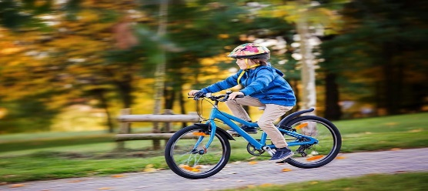
Induction/Introduction ( Generating interest, informing students about the outcomes and expectations for the lesson)
- What happens if team members play their own game without coordinate with each other?
- What is the importance of coordination?
- Who coordinate the team members?
- What are the body parts that working in boy’s body while bicycling?
- Who coordinates these systems?
Experience and Reflection (Task/question that helps students explore the concept and connect with their life)
- How can we decide whether it is good or bad?
- How can we take the decision when we are in critical situation?
- How can we remember the things and situations from childhood?
- Why can’t we control the emotions some times?
Explicit Teaching/Teacher Modelling (I Do)  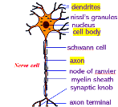  - Discussion on stimulus and response.  - Observation of Structure of nerve cell (Activity-2)  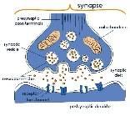  - Discussion and picture illustration on nerve cell, its connections (synapse) and different pathways from stimulus to response.  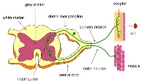  - Discussion and picture illustration on the reflex arc.  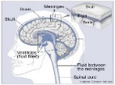  - Discussion and picture illustration on Central nervous system- Brain, spinal cord and their functions.  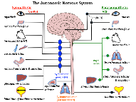  - Discussion and picture illustration on Peripheral nervous system- cranial nerves, spinal nerves, autonomous nervous system and their functions.  - Discussion on Endocrine system (Coordination without nerves, Other chemical coordinators) and feedback mechanism.  - Discussion on control mechanisms in plants.  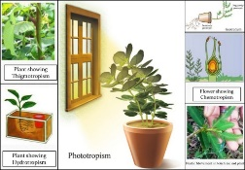 |  | Group Work (We Do)  - Holding a falling stick activity. (Activity-1)  - Observation of knee jerk reflex (Activity-3)  - Analysis and interpretation of the data in the endocrine glands table.  - Observation of phototropism and geotropism (Activity-5)  - Analysis on plant hormones and their functions.  Discussion on tropic and nastic movements in plants.  - Observation of movements in Mimosa pudica (Activity-4)  - Provide the vocabulary related to nervous system such as stimuli, response, receptors, effectors etc, and make the students write their own sentences to describe those words.  - Prepare some questions to analyses the data given in the plant hormones table.  - Make the students prepare a questionnaire to interview a doctor (endocrinologist) regarding the glands like pancreas and their health.  - Conduct a seminar on contributions of different scientists in understanding of coordination in plants and animals  - Group discussion on Emotions – their control. (Let the students recall various emotional conditions they went through, and the after-effects of emotions, relate them with the nervous system and endocrine system and discuss the methods and need for management of emotions.) | Independent Work (You Do)  - Draw the charts showing nerve cell, synapse, brain, reflex arc  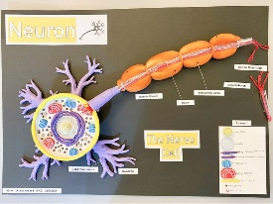  - Prepare a modal of nerve cell and brain using available materials.  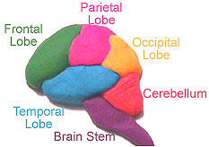  - Prepare flow charts showing different paths followed by nerve impulse during different actions (Creativity, Critical thinking)  - Give the flow chart showing path followed by impulse during reflexes and let them explain the process in their own words.  - Make the students prepare their own sentences using the hints given in the table. (Using preposition to)  Response of a plant to light Is called Phototropism  Gravitational force geotropism  water hydrotropism  make contact/ touch thigmotropism  chemicals chemotropism

Check For Understanding Questions  - Factual:  - What are the differences between stimulus and response?  - What is receptor?  - What are the parts present in the brain?  - What are the components in reflex arc?  - What is gland and hormone?  - What is photo tropism?  - Open Ended / Critical Thinking:  - What happen if all functions of the human body are controlled only by brain?  - If you visit a doctor what doubts you would like to clarify about pancreas?  - What will happen to the potted plant kept near window in the room?  - What suggestions will you give to your friends to control emotions?  Student Practice Questions & Activities (Exercises from workbook / textbooks/ blackboard)  - How does Phototropism occur in plants?  - Give an example and explain how plants may immediately respond to a stimulus  - Suggest an experiment to show how roots grow away from light in most plants.  - Give an example to show how hormones can influence visible changes in your body.  - How does a neuron differ from an ordinary cell in structure? Write notes | TLMs (Digital + Print)  Resources: Use the given Do ID to get the digital content related to this chapter on Diksha : For nervous coordination  https://diksha.gov.in/play/content/do_31320682608158310418702  For endocrine coordination:  https://diksha.gov.in/play/content/do_431343628414958796812163  For coordination in plants:  https://diksha.gov.in/play/content/do_31320682599277363217089  Use the language lab pen drive resource.  Some of the other digital resources are:  https://www.youtube.com/watch?v=18oQ95kVr1M&list=PLO4AH4RMd9SqSY7qQyxjOsRGh8EZMkAv3  Charts showing Nerve cell, brain, spinal cord, reflex arc, autonomous nervous system, endocrine system, phytohormones etc,.  Modals of Nerve cell, brain, spinal cord, reflex arc, endocrine system.  Scale, glass beaker, soil, seeds, potted plant etc,.  Intermediate botany and zoology text books.
Assessment (Think of what children SAY, DO and MAKE while learning that can form the evidence of learning to be used for assessment).
- Write the Differences between
- Stimulus and response, Afferent and efferent nerves,
- Central nervous system and peripheral nervous system,
- receptor and effector,
- tropic and nastic movements.
- Write an experiment to observe the impact of phytohormones on plant growth.
- How can you relate the parts of brain with their functions?
- Explain the process of nerval coordination in human beings.
- Draw labelled diagrams of
- Nerve cell b) Reflex arc c) Flow charts such as path followed by impulse in the body.
- Study the Phytohormones table and answer the following.
- What are the plant growth promoting substances?
- What are the plant growth inhabiting substances?
- Which phytohormones are impacting seed germination?
- Who coined the word hormones?

SIGNATURE OF THE TEACHER SIGNATURE OF THE HEAD MASTER

VISITING OFFICER WITH REMARKS

