MODEL LESSON PLAN FOR ALL TYPES OF HIGH SCHOOLS
CLASS : 10 SUBJECT: Biology Name of the Teacher : Name of the School:

Name of the Lesson/Unit | Topic | No. of Periods  Required | Time line for teaching |  | Any specific  Information
 |  |  | From | To
Excretion | Human excretory system | 2
 | Mechanism if excretion | 2
 | Dialysis, Kidney transplantation and accessory organs, Evolution | 2 |  |  | Awareness camp on kidney failure, Dialysis and organ donation.
 | Excretion in plants | 2

Prior Concept/ Skills: (Essential concepts and skills to be checked/bridged before teaching the current concept.)
Waste products of photosynthesis, digestion, Respiration, and circulation. Different organs like lungs, gut, liver, kidney, skin, gums from plants, nitrogenous compounds like urea, ammonia, bile juice, blood tests and reports, urine tests and reports. Etc.,
Learning Outcomes: (Select from SCERT Academic Calendar and Textbook)  - Differentiates Excretion and Secretion, Primary metabolites and secondary metabolites.  - Classifies the plant products in to primary metabolites and secondary metabolites, materials in to excretions and secretions.  - Plans and conducts investigations / experiments to observe the structure of mammalian kidney.  - Relates the concentration of urine with secretion of vasopressin & seasons, composition of urine with food intake  - Explains processes of excretion in plants, animals and human beings.  - Draws labelled diagrams / flow charts / concept map of excretory system, nephron, formation of urine.  - Analyses and interprets data regarding excretory organs and alkaloids.  - Applies learning to hypothetical situations, such as what happens if waste materials are not removed from the body?  - Applies scientific concepts in daily life such as habits to be follow for proper function of kidneys.  - Exhibits creativity in designing models using eco-friendly resources, such as excretory systems.  - Exhibits values of rational thinking / freedom from myth / superstitious beliefs while taking decisions, respect for life, etc. Such as motivates for organ donation. | No. of Periods:  8

TEACHING LEARNING PROCESS
Induction/Introduction (Generating interest, informing students about the outcomes and expectations for the lesson)
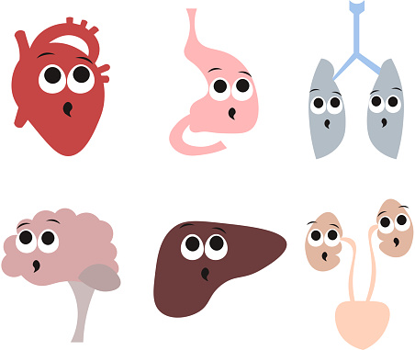
- What do you notice in these pictures?
- What are the waste products that you found in kitchen?
- Do you notice the waste after eating food?
- Can you give examples of waste material from your nearest factory?
- Is it possible to produce any product without releasing waste?
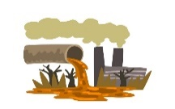
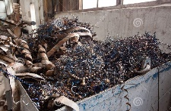
- What happens if we not remove the vegetable waste from kitchen?
- Do you agree that some waste materials are produced from our body?
- What happens if our lungs not remove the waste from blood?
- Which organs remove waste from our body?

Experience and Reflection (Task/question that helps students explore the concept and connect with their life)
- Where are the wastes produced?
- How are they produced?
- What are the substances present in them?
- Does the composition vary in the same organism in different situations?
- What products would the organism be able to take up for other activities?
- What products which would cause harm to the body, if they are not removed?
- What happens if harmful products are not removed from our body every day?
Explicit Teaching/Teacher Modelling (I Do) | Group Work (We Do) | Independent Work (You Do)
- Discussion on excretion – excretion in human beings  - Studying the external and internal features of a kidney. (Lab activity)  - Discussion and picture illustration on structure of Human excretory system – kidney, nephron, ureters, urinary bladder, urethra  - Discussion and picture illustration on mechanisms of urine formation.  - Discussion on micturition, composition of urine.  - Discussion on ESRD, Dialysis and Kidney transplantation.  - Discussion and analysis on Excretion in other organisms.  - Discussion on excretion and release of substances in plants.  - Discussion and Analysis of information regarding secondary metabolites such as alkaloids, tannins, resins, gums and latex.  - Discussion on Excretion and Secretion | - Give a flow chart showing mechanism of urine formation and make the students prepare their own notes on it in their own sentences.  - Make the students prepare their own sentences using the hints given in the table.(Using preposition through)  Platyhelminthes Flame cells  Nematoda Rennet cells  Annelids Nephridia  Arthropoda Green glands, Malpighian tubules  Mollusca Meta nephridia  - Make the students prepare some questions to analyses the data given in the alkaloids table.  - Make the students prepare a questionnaire to interview a nephrologist/ urologist regarding the health of the kidneys.  - Awareness camp on kidney failure, Dialysis and organ donation.  - Conduct a seminar on organ donation. Make the students prepare some slogans about organ donation and carry out a rally to create awareness (communication, Collaboration, Creativity) (S. Club) | - Draw the charts showing Human excretory system, internal structure of kidney and nephron (Creativity)  - Prepare a modal of human excretory system using available materials. (Creativity)  - Prepare flow charts showing mechanism of urine formation (Creativity, Critical thinking)  - Group discussion on Brain dead. (SEL)  - Discussion and picture illustration on other pathways of excretion.

Check For Understanding Questions  - Factual:  - What is excretion?  - What are the excretory organs in our body?  - What are the structural and functional units of the kidney?  - What is ESRD and uremia?  - What are secondary metabolites in plants?  - Open Ended / Critical Thinking:  - Imagine what happens if waste materials are not sent out of the body from time to time?  - To keep your kidneys healthy for long period what questions will you ask a nephrologist/ urologist?  - Is there any problem if we donate one kidney? Who can donate?  - Just imagine why we can not store the waste materials like plant?  - What happens if ESRD person fail to do dialysis regularly?  Student Practice Questions & Activities (Exercises from workbook / textbooks/ blackboard)  - How are waste products excreted in amoeba?  - How plants manage the waste materials?  - Why do some people need to use a dialysis machine? Explain the principle involved in?  - What is meant by osmoregulation? How is it maintained in human body?  - What are the gum yielding trees in your surroundings? What procedure you should follow to collect gum from trees? | TLMs (Digital + Print)  Use the given Do ID to get the digital content related to this chapter on Diksha :  https://diksha.gov.in/play/content/do_31320682592659865618189  Use the language lab pen drive resource.  Some of the other digital resources are:  https://youtu.be/IrTOSHZzpAU  https://youtu.be/SdlPLLu5LWA  https://youtu.be/8LWW1gEAex8  Charts showing kidney, nephron, excretory organs in animals and excretory products in plants.  Modals showing kidney and nephron.  Goat kidney, tray, water, dissection box etc,.  Intermediate text books.
Assessment (Think of what children SAY, DO and MAKE while learning that can form the evidence of learning to be used for assessment).
- Write differences between
- Excretion and Secretion,
- Primary metabolites and secondary metabolites.
- excretions and secretions.
- Classifies the plant products in to primary metabolites and secondary metabolites.
- Write procedure to observe the structure of mammalian kidney.
- What is the relation between the concentration of urine with secretion of vasopressin and seasons, composition of urine with food intake
- Explain the processes of excretion in plants, animals and human beings.
- Draw labelled diagrams
- Human excretory system
- Internal structure of kidney
- Nephron
- flow charts showing formation of urine.
- Observe the alkaloid table and analyses it. Then answers the questions?
- Make a model of kidney or human excretory system by using eco-friendly resources
- We people have very less awareness about organ donation, to motivate people write slogans about organ donation?
- After learning this chapter what habits you would like to change or follow for proper functioning of kidneys?

SIGNATURE OF THE TEACHER SIGNATURE OF THE HEAD MASTER

VISITING OFFICER WITH REMARKS

